Nectar-feeding bats learn the rule behind serial reversals

Shambhavi Chidambaram1,2, Sabine Wintergerst3, Alex Kacelnik4, York Winter1,2*, Vladislav Nachev1

1 Institute of Biology, Humboldt University, Berlin, Germany

2 Berlin School of Mind and Brain, Humboldt University, Berlin, Germany

3 Fairchild Tropical Botanic Garden, Miami, USA

4 Department of Zoology, University of Oxford

**\*For correspondence:** [york.winter@hu-berlin.de](mailto:york.winter@hu-berlin.de)

**Present Address:** Institute of Biology, Humboldt University, Philippstr. 13, 10115 Berlin, Germany

# Abstract

Animals that show flexibility in their behavioural responses to environmental change have a strong advantage in foraging for food. We aimed to explore this ability in Commissaris’s long-tongued bat through a spatial serial reversal learning task. Wild bats were trained to obtain rewards from two artificial flowers. At any given time only one of the flowers provided a reward. After the bats had experienced the rewarding properties of the flowers for some time, a reversal happened: the rewarding flower became non-rewarding and vice versa. These reversals of rewarding properties occurred repeatedly.

We found that the bats responded swiftly to the reversals of reward properties: when a food location suddenly dried up they quickly abandoned visiting it and switched to the alternate option, showing a near-exclusive preference for the rewarding option. After experiencing multiple such serial reversals the bats chose the rewarding flower more frequently overall, but less frequently over the course of a single night. The bats also switched to the rewarding flower more swiftly as they experienced multiple reversals, but only up to a point. These results show that reinforcement learning drives the bats’ choice behaviour; and, to an extent, the bats learn the rule behind the environmental change, which is evidence of higher-order learning. The question of whether nectar-feeding bats can understand other predictable but more complex environmental patterns produced by the deterministic process of floral nectar secretion, or even potentially anticipate and predict them, is an exciting one for further research.

# Introduction

Many animals live and forage in environments that change frequently and often unpredictably. The foraging environment of nectar-feeding animals mainly consists of flowering plants and the food resource they provide: nectar. Though flowers – and their nectar contents – are stationary, they bloom seasonally and single flowers on plants themselves wither and die every day or every few days, altering their efficacy with time as food resources. Thus, nectar-feeding animals face the challenge of exploiting resources that continually change with time but are relatively predictable in space. These animals need to detect the changing reward contingencies in their environment and adjust their behaviour accordingly.

Behavioural flexibility is one possible strategy to cope with such changes. The word ‘flexibility’ has been used to mean many different things in the animal behaviour literature (often inconsistently – Audet and Lefebvre 2017), and one interpretation of the word is similar to the concept of elasticity: behavioural patterns that can be repeatedly and readily reversed (Bond et al., 2007). One experimental protocol that has been widely used to test for and demonstrate this sort of behavioural flexibility is reversal learning.

Reversal learning essentially involves two separate stages of learning. An animal must first learn about multiple stimulus response associations and to discriminate in their behaviour amongst them. These can be two spatial locations that potentially provide a food reward. The animal is then confronted with a situation where only one of the two options is profitable. Under these conditions, it is optimal to pay attention only to this option. After a longer series of such repetitive stimulus response actions, the experimenter halts the reinforcement. The optimal strategy for the animal then is to immediately abolish its recent behaviour and instead perform another stimulus-response action that in the past had proven profitable. It is this ability to abruptly terminate a repeated behaviour and switch to a more beneficial one that the animal needs to have for efficient exploitation of the available resources. In a serial reversal learning procedure the reward contingencies reverse repeatedly. An animal that responds to the rewarding stimulus more frequently than to the non-rewarded stimulus receives food more often and performs more efficiently on the task. In contrast, choosing the non-rewarded stimulus is an ‘error.’ Successful performance critically depends on the animal ‘s ability to switch abruptly after a reversal.

Improvement in the reversal learning task is clearly demonstrable and is therefore a meaningful criterion when comparing the performance of different species. In this respect, two levels of learning should be distinguished. First-order learning happens when an animal perceives a stimulus and learns which behavioural response leads to a reward – the stimulus-reward association – and changes its behaviour according to the strength of this reinforcement. Second-order learning is the learning of rules or strategies for making such behavioural switches. It entails the ability to actually choose efficiently among potential behavioural responses in any given situation. In serial reversal learning, the same stimuli are successively paired with a reward and then not paired with a reward. Under such conditions, animals must learn the second-order rule to quickly abandon a suddenly unsuccessful response that previously resulted in reward. A rule that can maximize reward in a deterministic, reversal learning schedule is ‘win-stay; lose-shift’: repeat the behaviour which produces a reward until it stops being rewarding, and then immediately switch to another behavioural response. Such a rule means that the animal makes exactly one ‘error’ per reversal. After an animal learns the task, perfectly optimized behaviour will involve a response exclusively to the rewarded stimulus. After the first instance of a behaviour leading to a lack of reward (the error), the animal will change its actions and exclusively respond to the other stimulus which is now paired with a reward.

Animals are rarely, if ever, so finely-tuned in their behaviours in real life. Large and deterministic changes are uncommon in nature and more gradual shifts in behaviour may be better suited to natural environmental changes. For this reason, win-stay lose-shift in practice means an animal will repeat the behaviour that produces a reward after one or a few experiences of reward, and switch to another behavioural response after one or a few errors leading to experiences of no reward. Errors in reversal learning tasks are common and can occur in different ways. An animal can persevere, continuing to choose a non-rewarding cue after the reversal has occurred or they can make anticipatory errors, changing their behaviour and choosing the other cue before a reversal has occurred. Progressive ‘improvement’ in this task, where an animal makes fewer and fewer errors of either type per reversal is indication that higher-order learning, or ‘learning to learn’, is occurring (Shettleworth 2010).

To investigate the flexibility of responding to depleting food locations we carried out a serial reversal learning task with Commissaris’s long-tongued bat, (*Glossophaga commissarisi*), which primarily feeds on flower nectar. The bats were given two potentially rewarding options to choose between. The two options were separated in space and their spatial location was the cue to indicate their reward properties at any moment. *G. commissarisi* is known to have excellent spatial memory (Thiele and Winter, 2005) so no other cue was necessary. At the start of the night, only one of the options was rewarding, the ‘S+’ option and the other was not rewarding, the ‘S-’ option. After a certain number of visits had been made by the bats, the reward contingencies reversed without any signal or cue to the bats: the previously rewarding option was now unrewarding and the previously unrewarding option was rewarding, and this reversal happened five times in a night.

Our aims with this experiment were as follows. First, we wanted to test how the bats would alter their preference between the two reward sources according to their transient rewarding properties; that is, would the bats show first-order learning? Second, if the bats did alter their behaviour in response to the changing reward properties, how did the occurrence of successive reversals affect that behaviour? For example, the behavioural allocation between the two options might change more swiftly as the bats experienced more reversals. In other words, would the bats show higher-order learning? Third, we wanted to see how closely the bats could approach the optimal strategy in such an environment: one error per reversal achievable through the win-stay, lose-shift strategy.

After the analyses described above were done and the data and results examined, we performed further analyses to explore the conclusions of our confirmatory analyses. The difference between these results must be clearly noted. We reasoned that there is a difference between the first visits of a night, before any experience of a change in contingencies, and all the subsequent visits after at least one reversal had occurred. We statistically tested for this difference in the bats’ choice behaviour and compared the results of the confirmatory and exploratory analyses.

# Methods

## Study site and subjects

The experiment took place at La Selva Biological Field Station, Province Heredia, Costa Rica in June-July 2017. Bats of the species *Glossophaga commissarisi* were captured from the wild and retained in a flight cage through the experiment. The bats were attracted to a particular location in the forest using chicken-feeders filled with sugar-water (see Reward below) as bait. The feeders had cotton swabs soaked in dimethyl disulphide on them, a chemical attractant produced by many bat-pollinated flowers [@von_helversen_sulphur-containing_2000]. and then caught in mist-nets. The bats were sexed on capture and housed in two outdoor, meshed flight-cages (4 x 6 m) under ambient light conditions. All individuals were weighed and marked with radio frequency identification (RFID) tags placed as collars around their necks.

A total of 16 bats participated in the main experiment and the first stage of the experiment began on the same night the bats entered the cages. A group of four experimental bats of the same sex were placed in a flight cage together. Two such groups were run in parallel, one in each flight-cage so the data were collected simultaneously. Two groups were run in parallel, one in each flight cage, and the data were collected simultaneously. At the end of the experiment, the RFID collars were removed and the bats were released back into the wild. All the data collection was completely automatized. Two of the bats did not drink a sufficient amount of sugar-water to meet minimum energy requirements; they were released before the end of the experiment and not replaced, and the data from these two individuals were not analyzed. Thus, 14 bats (7 males and 7 females) completed the experiment. Permission for this research was granted by Sistema Nacional de Areas de Conservación (SINAC) at the Ministerio de Ambiente y Energía (MINAE), Costa Rica.

## Experimental Setup

### Reward

The reward received by the bats during the experiment was also their main source of food. The reward was a 17% by weight solution of sugar dissolved in water, hereafter referred to as ‘nectar.’ The sugar consisted of a 1:1:1 mass-mixture of sucrose, fructose and glucose. The nectar was thus similar in composition and concentration to the nectar produced by wild chiropterophilous plants [@baker_sugar_1998]. Every night, the bats were also given ad-libitum access to 10 mL of supplemental food: 3.5 g of hummingbird food (NektarPlus, Nekton, Germany) and 3.5 g of milk powder (Nido 1+, Nestle, Switzerland) in 10 mL of water. They were also given a small bowl of locally-sourced bee pollen.

### Flower and pump setup

Each flight cage had a square plastic frame in the center (2 × 2 × 1.5 m). Eight reward-dispensing devices - hereafter referred to as ‘flowers’ - were fixed in a radial pattern on this frame, two on each side of the square (see Figure 1) with a distance of 40 cm between adjacent flowers. At this distance, bats can easily discriminate neighbouring flowers [@thiele_hierarchical_2005]. Each flower had the following parts: an RFID reader mounted on a plastic cylinder around the head of the flower; an infra-red photo gate; and an electronic pinch valve through which a silicon tube was placed and fixed to the head of the flower.

A stepper-motor pump was placed in the center of the plastic frame in each cage. The pumps contained a 25 mL Hamilton glass syringe (Sigma Aldrich, Germany). The step volume of the two pumps differed slightly: the pump in Cage 1 delivered 2.11 L per step of the stepper-motor, whereas the pump in Cage 2 delivered 3.33 L per step. The glass syringe was connected to the tubing system of the flowers through five pinch valves [@nachev_psychophysics_2012]. The pinch valves controlled the flow of liquid from the pump to the system and from a reservoir of liquid to the pump. The reservoir (500 mL thread bottle, Roth, Germany) was filled with fresh nectar every day and was connected to the syringe through the valves.

Every day at around 1000 h, the old nectar was emptied from the system, which was rinsed and filled with plain water until 1500 h, when it was filled again with fresh nectar. Twice a week, the system was filled with 70% ethanol for an hour to prevent microbial growth, then repeatedly rinsed with water.

When a tagged bat approached a flower, the individual RFID number was read. If the bat then poked its nose into the flower and interrupted the light beam, it triggered the release of a reward. The pinch valve opened and the pump moved the correct number of pre-programmed steps to dispense nectar to the head of the flower. The bat could easily hover in front of the flower and lick up the nectar. A reward was given only when both events occurred, i.e., the RFID reader identified a bat and the photo gate was triggered. The flowers and the pump were connected to a Windows PC, which ran the experimental programs and the program used to automatically flush, clean and fill the pump and tubing system (PhenoSoft Control, PhenoSys, Germany).

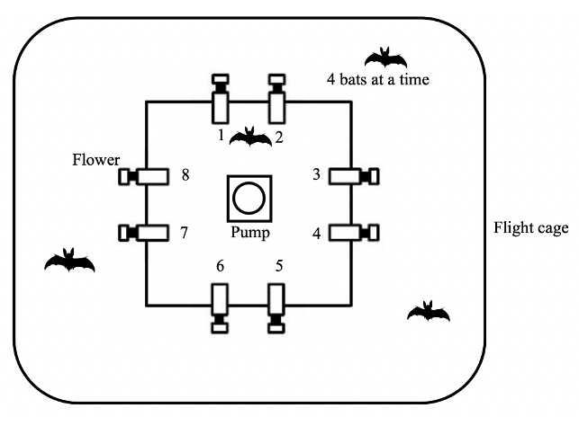

Figure 1: Schematic of the cage and flower set-up

## Experimental procedure

Out of the array of eight flowers, each bat was uniquely assigned two adjacent flowers on the same side of the square frame, programmed to reward only one of the four bats in the cage. After the system was filled with fresh nectar at approximately 1700 h, the program was left running for data-collection till the next morning. Thus, the bats could begin visiting the flowers to collect a reward whenever they chose, which was at nightfall at approximately 1800 h every night. During the main experiment, the bats could make a maximum of 300 visits a night.

During the course of the night, when the syringe of the pump had been emptied, the pump re-filled automatically. This event happened only once every night. On the main experimental days, this process took 4.5 minutes (SD = ±0.18) for the horizontal pump, and 2.4 minutes (SD = ±0.04) for the vertical pump.

About 1% (SD = ±0.74) of all visits made by the bats over all three experimental nights were wrongly unrewarded: the bats did not receive a reward during these visits even when they were made to a flower assigned to them that was rewarding at the time. This happened either during the pump refill times or when the pump was moving to reward a visit made by another bat that happened almost at the same time. Such events did not count towards the total of 300.

## Experimental design

The experiment proceeded through the following stages.

### Training

On the night the naïve bats were captured and placed into the flight cages, they could receive a reward from any of the flowers whenever they visited them throughout the night. To enable the bats to find the flowers, a small cotton pad soaked in dimethyl disulphide was placed on each flower. A small drop of honey was applied to the inside of the flowers to encourage the bats to place their heads inside, interrupt the photo gate, and trigger a nectar reward. By the end of the night, all the bats had found the flowers and learned to trigger rewards.

The next stage of training involved assigning the bats uniquely to two out of the eight flowers in the array. For an individual animal, only the two flowers assigned to it would elicit rewards from this stage of training until the end of the experiment. This stage was similar to the previous one, except the bats could only trigger a reward at their assigned flowers, and the chemical attractant and honey were not used.

To ensure that the bats were familiar with both flowers assigned to them, they went through one final stage of training: forced alternation. The bats received a reward at one of the two flowers for one trial, and then could only receive reward at the other flower for the next trial. In this way the bats had to alternate between the two flowers every single trial.

### Serial Reversal Learning Task

In the serial reversal learning task, the bats had continuous access to two flowers: one that gave a 40-L nectar reward, and one that remained empty. The location of the rewarding flower was not cued; however, after completing the alternation training phase, each bat knew the locations of both flowers that were potentially rewarding to it. After a bat had made 50 visits in total to the two flowers (regardless of relative allocation), a reversal occurred: the previously rewarding flower became the non-rewarding flower and *vice versa*. Importantly, only visits to the two flowers assigned to a bat counted towards the visit tally. Each set of 50 visits to the assigned two flowers, either at the start of each night or between reversals, was termed a ‘block’. There were six blocks and five reversals per night, unless the bat ceased visiting earlier. This was repeated for three consecutive nights. The same flower started the sequence every night. Consequently, the last flower to be rewarding one night was non-rewarding at the start of the next.

## Data analysis

The raw data collected during this study were the computer logged events of feeder visits recorded in comma-separated value (CSV) files. Each event included the time stamp, animal ID, photo gate interruption duration and the volume of nectar dispensed. The CSV files were read into R, which was used for all statistical analyses and creation of plots.

All the statistical models were fitted in a Bayesian framework using Hamiltonian Monte Carlo in the R package brms [@burkner_brms_2017], which is a front-end for rstan (Stan Development Team, 2020). The details of these models are provided in the **Supplementary Material**.

Except when stated otherwise, all the visits made by the bats to their two assigned flowers - up to 300 - during a night were included in the analyses (some of the bats did not complete all 300 visits on every night). The bats made some visits and approaches to the flowers that were not assigned to them; however, these were the minority, and were not considered for the analysis (see **Supplementary Material** for details). At the end of each of the first five blocks, a reversal occurred; the end of the last block was the end of data-collection for the night. Each block was further divided into five bins of ten visits, in order to examine the bats’ behaviour within each block. Generalized linear mixed models were used for the analyses (see **Supplementary Material** for details of the model fitting). We report here the mean as a measure of central tendency and the 89% quantile-based credible intervals for the parameters. (89% boundaries are the default for reporting credible intervals - [@mcelreath_statistical_2020]). However, as raw parameter values can be difficult to interpret in models with interaction terms, we also present plots of the conditional effects of the predictor variables. Such plots show the effect of predictor variables and their interactions, sampled from the posterior distribution, but conditional on the other predictors being equal to their means.

We investigated the effect of experimental night and block on the number of perseverative visits, i.e., consecutive visits to the previously-rewarding option just after the occurrence of a reversal; and the effect of experimental night, block and bin on the proportion of visits to the rewarding flower. The proportion of visits to the rewarding flower was calculated as the number of visits to the S+ divided by total number of visits to both the S+ and S-, and we denote this as the Proprew:

After examining these results, we conducted further post-hoc exploratory analyses. We investigated the effect of the first night and first block of a night as predictor variables separate from the later two nights and the later five blocks on Proprew. This was because the animals had had no prior experience of any reversals on the first night, and during the first block of every night, they had not yet experienced any reversals. Thus, night and block were taken as categorical variables with levels ‘first night’ and ‘later nights’; and ‘first block’ and ‘later blocks’ respectively.

A few of the results report 95% confidence intervals, as opposed to credible intervals, and these are noted specifically. The confidence intervals were calculated by non-parametric bootstrapping without assuming a normal distribution of the data, using the Hmisc package, which is part of the tidyverse system of R packages [@wickham_welcome_2019].

All statistical analyses and creation of plots were done in R.

## Data availability

All data and analysis code are available online at …..

# Results

## Confirmatory analyses

### Bats made the majority of their visits to the rewarding option

The bats made a very high number of visits to the rewarding option, quickly abandoning an option when it stopped being rewarding after a reversal and switching to the other (Figure 2). A consistent pattern emerged over all three nights: a sharp decrease in the proportion of visits to the formerly rewarding option immediately following a reversal, concomitant with a rapid increase in visits to the newly rewarding option. There are two particularly interesting points about this overall pattern: the behaviour during the first bins of each block; and the changes between the first night and the following two nights.

At the start of the first night, in the very first bin of ten visits when the bats did not yet have any information about the available options and had never experienced a reversal, the Proprew (the proportion of visits to the rewarding option) averaged across individuals was close to chance: 54.5% [95% CI 46.8, 62.3]. Within the next ten visits however, Proprew increased to 92.1% [95% CI 87.1, 96.4] and by the last bin of this first block was 99.3% [95% CI 97.9, 100]. Immediately after the first experience of a reversal, the Proprew dropped down to 13.6% [95% CI 8.4, 18.8] in the first ten visits, but came back up to 96.4% [95% CI 92.9, 99.3] by the last bin of this block.

At the very start of the second and third nights, in the first bin of visits before any experience of a reversal on that night, the average Proprew of all the bats was 69.8% [95% CI 64.6, 74.7], about 7 out of the 10 visits. This was significantly higher than random choice and higher than the Proprew in the corresponding bin of the first night. For the remainder of these nights the Proprew showed a similar pattern to the first night: a decrease immediately after the reversal and then an increase to near 100%: 94.8% [95% CI 94.1, 95.5], comparable to the 93% [95% CI 91.8, 94.1] on the first night.

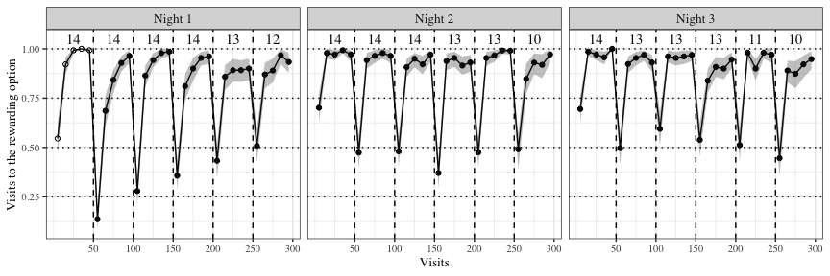

Figure 2: Visits to the rewarding option out of the two potentially rewarding options across the three experimental nights. Data are average proportions for bins of ten visits averaged over all 14 individuals. Data are indicated by white points in the first block on the first night before the bats had experienced any reversals; the bin averages of the other blocks are indicated by black points. Numbers indicate the bats that participated in a block. Shading shows 95% confidence intervals. Dashed lines show reversals

### Bats switched to the rewarding option faster as they experience more reversals

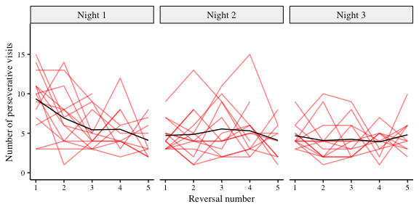As the bats experienced more reversals, they made their first visit to the rewarding flower faster and faster. Immediately after a reversal, the number of visits to the previously-rewarding flower (perseverative visits) decreased as the animals experienced more reversals (Figure 3). The analysis showed however that this change occurs mostly on the first night (Figure 4 and Figure 5). It would appear therefore, that the bats get faster at responding to reversals, i.e., make fewer perseverative visits only on the first night until they reach a plateau, and this plateau persists over the second and third nights. Thus, the bats never reached the optimal performance of one error per reversal.

Figure 3: Number of perseverative visits made by the bats after each reversal across all three nights. A perseverative visit is a visit to the previously-rewarding option after a reversal and before any visit to the newly-rewarding option. By definition, there were no perseverative visits in the first block of a night. The red lines show individual data and the black lines the group average (N = 14). Reversals were between the two flowers assigned to an individual bat

*Figure 4: Forest plot of the estimates of the effect of night and block on perseverative visits. Circles represent the means of the posterior distributions of the slope coefficients, thick horizontal lines represent 50% credible intervals, and thin horizontal lines 89% credible intervals. The numbers in bold are the means of the posterior distributions and 89% credible intervals*

*Figure 5: a) Conditional effects of experimental night on the number of perseverative visits b) Conditional effects of block on the number of perseverative visits c) Conditional effects of the interaction of experimental night and block*

### Bats made more visits to the rewarding option over all three nights, but fewer over the course of each night

As the experiment proceeded and the bats experienced more reversals on more nights the overall proportion of the animals’ choices for the rewarding flower changed (see Figure 2). Within each block the change in the Proprew was very large, showing a rapid increase from less than 0.7 at the start of a block, when the animals had either experienced the start of the experimental night or a reversal, to more than 0.9 by the second bin of 10 visits. We saw no evidence of anticipatory errors whatsoever. Across the three nights the animals’ choices for the rewarding flower also increased. However, there was a decrease within each night in the Proprew: the bats made fewer visits to the rewarding flower at the end of the night compared to the start of the night.

As the results of the statistical analysis are summarized in Figure 6 and Figure 7. These results show the bats made an increasing number of visits to the rewarding option as each block progressed from its start to the next reversal, and as they experienced more experimental nights. However, this increase was dampened over the course of each individual night.

*Figure 6: Forest plot of the estimates of the effect of night, block, bin and their two-way interactions on the Proprew. Circles represent the means of the posterior distributions of the slope coefficients, thick horizontal lines represent 50% credible intervals, and thin horizontal lines 89% credible intervals. The numbers in bold are the means of the posterior distributions and 89% credible intervals*

*Figure 7: a) Conditional effects of experimental night on the Proprew b) Conditional effects of block on the Proprew c) Conditional effects of bin on the Proprew d) Conditional effects of the interaction of night and block on the Proprew e) Conditional effects of the interaction of block and bin on the Proprew f) Conditional effects of the interaction of night and bin on the Proprew*

## Exploratory analyses

### The effect of the first experimental night and the first block of each night

The first block of an experimental night was qualitatively different from the other blocks, as this was the only part of the night when the bats had not yet experienced a reversal. A similar argument can be made about the very first experimental night: before this night the bats had never experienced a reversal at all. Therefore, after examining the results of the analyses described above, we did a further analysis to specifically explore the effects of the first block of a night and the first night.

The results of this analysis are summarized in Figure 8 and Figure 9. The first block of a night had an effect on the Proprew: the bats made more visits to the rewarding option in the very first block of a night compared to all the later blocks. This effect was greater on the very first night compared to the later two nights, i.e., on the very first block of the very first night when the bats had experienced reward at only one option, and no reversals at all. This is consistent with the results of the confirmatory analysis, which showed that the 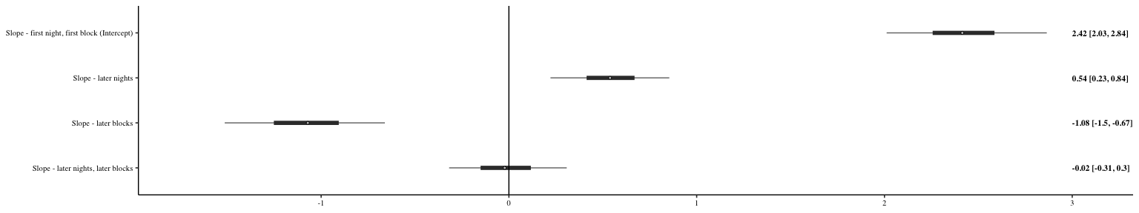number of visits to the rewarding flower decreased from the start to the end of a night.

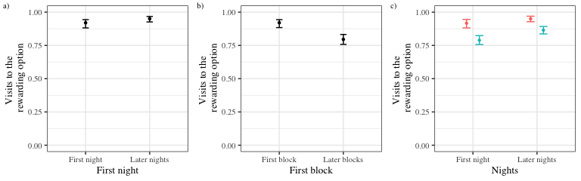*Figure 8: Forest plot of the estimates of the effect of night, block, bin and their two-way interactions on the Proprew. Circles represent the means of the posterior distributions of the slope coefficients, thick horizontal lines represent 50% credible intervals, and thin horizontal lines 89% credible intervals. The numbers in bold are the means of the posterior distributions and 89% credible intervals*

Figure 9: a) Conditional effects of first and later experimental nights on the Proprew b) Conditional effects of first and later blocks on the Proprew c) Conditional effects of the interaction of the first and later nights and first and later blocks on the Proprew

# Discussion

In our experiment wild nectar-feeding bats participated in a spatial 2-AFC serial reversal learning task with two potentially rewarding options that repeatedly alternated their rewarding properties. We found that the bats quickly located the rewarding location and made most of their visits to it. The bats responded to their accumulating experience of reinforcement and lack of reinforcement in the serial reversal learning task by switching to the newly-rewarding option more swiftly and making a majority but decreasing number of their visits to the rewarding flower over the course of the night.

The first aim of our experiment was to see if the bats showed first-order learning by responding to the change in the flowers’ rewarding properties. This seemed unambiguously to be the case. The difference between something and nothing (which was the choice presented by the experiment) is the easiest possible discrimination test and the bats showed a near-exclusive preference for the rewarding option on all three nights. As the rewarding properties reversed between the two flowers, the bats re-established a high preference for the rewarding flower by the first bin of ten visits after a reversal and maintained it until the next reversal.

The second aim of our experiment was to see if the bats’ behaviour indicated the occurrence of second-order learning: a change that was due to their repeated experience of reversing reward properties. We detected two such behavioural changes: a decrease in the visits to the rewarding flower from the start to the end of each night; and an increase in the visits to the rewarding flower across the three experimental nights. The latter was a small effect compared to the former, probably because of a ceiling effect – the bats were making a high enough number of visits to the rewarding flower that any further increase had to be relatively small, especially when there were only three nights in total. Much more interesting is the decrease in the number of visits to the rewarding flower over the course of an experimental night. This is consistent with the findings from the exploratory analysis: the first block of a night is when the highest number of visits to the rewarding flower occur.

The third aim of the experiment was to see whether the bats’ choice behaviour approached the optimal strategy of one error per reversal. The number of visits immediately after a reversal to the previously-rewarding flower before the first visit to the newly-rewarding flower, which we term the perseverative visits, did in fact decrease on the first night but reached a plateau by the second night and did not decrease further. We infer from this result that a limited amount of rule-learning occurred.

When the animals receive a reward, i.e., reinforcement, at a particular location or associated with a particular cue, they are more likely to return to that location or cue. As bats were continually confronted with reversals, they learned a second reinforced response that was conditioned to another cue: the single or repeated absence of expected reinforcement. Reinforcement learning is the mechanism underlying the win-stay, lose-shift strategy and the two conditioned responses acquired through reinforcement learning in this experiment were the win-stay response and the lose-shift response. In other words, an animal’s tendency to choose a location or cue becomes a near-exclusive preference when reinforcement is experienced once or a few times and drops close to zero when a *lack* of reinforcement is experienced once or a few times. The role of the lack of reinforcement appears to be an important one: were this not the case we would expect to see an increase in the visits to the rewarding flower with an increasing number of experiences of reversal. In this way, the presence or absence of reward at a location or associated with a cue have the effect of respectively increasing or decreasing an animal’s tendency to approach that cue. Thus, as the bats experience multiple reversals over the course of a night, what they experience at each location is a generally high rate of reinforcement, but an increasing number of instances of a lack of reinforcement as well. We postulate that each reversal, and its consequent experience of a lack of reward at a hitherto rewarding location, had the effect of decreasing the animals’ tendency to return to the location, though the much more numerous instances of reinforcement nevertheless kept that tendency relatively high. This was why there was a decrease in the number of visits to the rewarding option over the course of a night. An alternative possibility is that as the bats ingest the nectar through the night, they become satiated and are thus less motivated to correctly revisit the rewarding flower (Murray and Rudebeck, 2013), but we do not believe this to be the case. This is because despite the decrease in visits to the rewarding flower with each reversal within a night, within each reversal block the highest number of such visits is just *before* the next reversal. If satiation was playing a role in decreasing motivation the visits to the rewarding flower would decrease as each block progressed, and not just as each night progressed. Second-order learning is evident: the bats abandon a recently rewarding location after a small number of experiences of no reward at that location and switch to the other location. A strong test of higher-order rule-learning is the transfer of improved performance at the serial reversal task from one sensory modality to another (Bond et al., 2007). Therefore, we suggest that a follow-up experiment to ours would be to examine if the bats can transfer their improved performance at the serial reversal task with one sensory modality, say spatial location, to another, say, echo-acoustic or olfactory cues.

Our results are consistent with previous work of the same species of bat under natural conditions in the same environment (La Selva Biological Field Station, Costa Rica). This study, using the serial reversal task, evaluated the behavioural flexibility of nectar-feeding bats to fluctuations in food resource availability. Free-flying, ID-tagged wild bats interacted with 50 ID-sensor equipped artificial flowers placed over a 100 x 100 m area in the open forest that varied in their rate of nectar production. The allocation of flower types to spatial locations changed with the same pattern every night (Thiele 2006). During each night, bats adapted to the changes in resource availability. However, they needed four nights before they had adapted to the underlying recurring, predictable pattern of resource variability.

In most cases under natural foraging conditions, flowers are emptied in a single visit, so win-stay is not often a profitable strategy. There are however certain plants such as species of *Agave* that hold large amounts of nectar, or *Vriesea*, which if undetected all night may hold so much nectar that it requires multiple hovering visits to deplete – “jackpot” rewards in other words (Ohashi and Thomson, 2005). Situations where lose-shift is the optimum response might be more common, but win-stay situations do occur in the bats’ foraging environments, and thus the ability to adopt a win-stay, lose-shift strategy is likely part of the bats’ natural foraging ecology as nectar-feeding animals.

The performance on the serial reversal task of animals that share similarities with bats in their foraging ecology is illuminating. Bumblebees – which consume nectar and pollinate flowers like our bats – in an experiment similar to ours with a large trial number (Strang and Sherry 2014) showed a reduction in their perseverative errors and an increase in the errors made in the last trials, though there is an overall decrease in the errors. The authors of this paper interpret these findings as potentially indicative of proactive interference, which occurs when previously-learned information interferes with the learning or remembering new information (Tello-Ramos et al., 2019).

Several animals that rely strongly on spatial memory have also been studied in reversal learning tasks, specifically birds that cache food at various locations that they must remember and return to. As Tello-Ramos et al. (2019) point out, birds that are known to have better or more long-lasting spatial memory such as black-capped chickadees (Hampton, Shettleworth and Westwood, 1998), Clark’s nutcrackers (Lewis and Kamil, 2006) and high elevation mountain chickadees (Tello-Ramos et al., 2018) were worse at adapting to the new contingency after a reversal than the initial learning. These data are consistent with the idea that there is a trade-off between acquiring new memories and retaining old ones, i.e., that proactive interference may be occurring in spatial reversal tasks, just like in bumblebees. It is known that Glossophagine bats not only have excellent spatial memory but that memory has been observed to last up to several weeks (Rose et al., 2016). It is certainly possible that proactive interference plays a role in the bats’ behaviour in the serial reversal task, but we believe that the simple reinforcement learning model outlined above explains the observed data adequately. Teasing out the role of proactive interference in nectar feeding bats’ decision-making behaviour is a separate line of inquiry and cannot be addressed by our simple experiment.

What performance on the serial reversal task says about the cognitive mechanisms at work is not completely settled. Cognitive flexibility describes the processes in the brain that underlie adaptive change in behaviour in response to changes in the internal or external environment (Dhawan et al. 2019). Cognitive flexibility cannot be directly observed; it is inferred to have occurred through behavioural flexibility (Tait et al. 2018). Behavioural flexibility does not necessarily indicate cognitive flexibility (Dhawan, et al. 2019) but has itself evolved in response to selection pressures from different foraging environments. Our study with nectar-feeding bats revealed a high capacity for behavioural flexibility and a limited but intriguing amount of rule-learning, which the bats’ foraging ecology, dominated by a search for nectar-rich flowers, has evolved in them.

**The following concluding paragraph is sort of a place-holder, but it’s there for now. It can be rewritten after a bit more discussion**

Our study of serial reversal learning in nectar-feeding bats showed that the animals chose the rewarding option in the vast majority of trials, but these choices decreased in response to repeated experiences of the reversal, indicating that learning was occurring both in response to reinforcement and the lack of it. Though the bats never reached the optimal behaviour of one error per reversal, the number of perseverative visits did decrease, potentially indicating a limited amount of rule-learning was occurring.

## Acknowledgements

We thank Alexej Schatz for the programming of the PhenoSoft Control software. We thank the members of the Winter lab, ___, __ and ___ for many useful discussions and our colleagues at La Selva Biological Field Station for all their support. We also thank ___ for their comments and suggestions for the improvement of the manuscript.

## Author Contributions

**SC**: data collection, formal analysis, data curation, writing – original draft, writing – review and editing. **SW**: conceptualization, experimental methodology, data collection. **AK**: formal analysis, writing – review and editing, supervision. **YW**: conceptualization, experimental methodology, resources, formal analysis, writing – review and editing, supervision. **VN**: formal analysis, data curation, writing – review and editing, supervision.

## Funding

Open Access funding enabled by …

## Availability of data and code

All data and code are available in the Zenodo repository …

# Declarations

## Funding

This work was funded partly by a scholarship from the Deutscher Akademischer Austauschdienst (DAAD) to SC. Support was provided by EXC ….. and EXC ….. [need to look up the two project numbers]

## Conflict of interest

YW owns PhenoSys equity

## Code availability

All data and code are available in the Zenodo repository …

## Open Access

Licenses

## Electronic Supplementary Material

## Visits and approaches to the unassigned flowers

Only two out of the array of eight flowers were assigned uniquely to each bat but all the flowers were accessible to all the animals. The number of approaches to and attempts to get a reward from all the flowers, both assigned and not assigned, is shown in Figure 10.

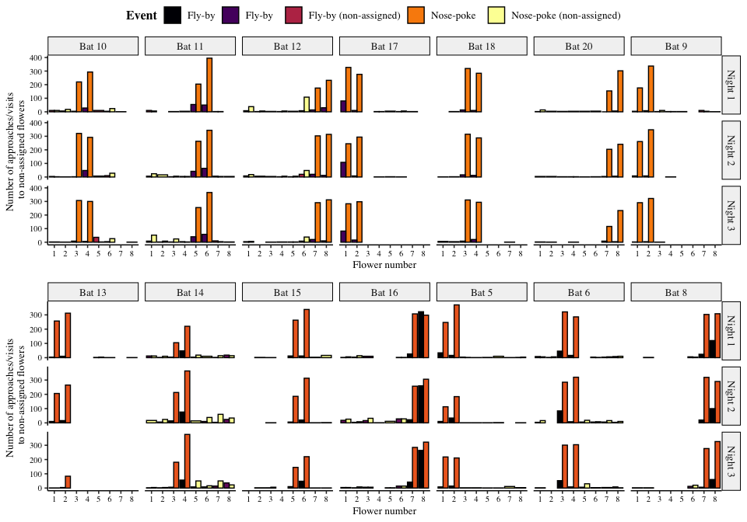

Figure 10: Visits made by the bats to all the flowers, including the ones that were not assigned to them. Yellow bars are nose-pokes at the assigned flowers, where the bats attempted to get a reward by breaking the light-barrier. Purple bars are ‘fly-by’ events near the assigned flowers where the bat flew near the flower but did not attempt to get a reward. Orange bars are nose-pokes at the non-assigned flowers and black bars are fly-bys at the non-assigned flowers.

The number of approaches or attempts to get a reward at the non-assigned flowers was a small proportion of the overall number of approaches and reward-attempts at the flowers, less than 10% every night on average as Figure 11 shows.

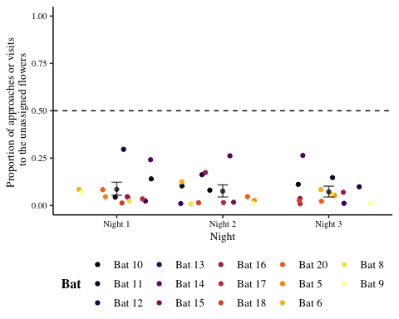

Figure 11: Proportion of visits or approaches to the un-assigned flowers out of the total number of visits or approaches to flowers. Coloured points are data from individual bats. Black points are the mean proportion per night and the error bars are 89% Cis

## Details of the statistical analyses

Weakly informative priors were used for the generalized linear mixed-models in brms. The random intercepts and slopes were given a Normal distribution with a mean of 0, and a standard deviation drawn from a Cauchy distribution with a mean of 0 and a standard deviation of 1. All the models were estimated using 4 chains with a thinning interval of 3, with 1200 warm-up samples and 1200 post-warm-up samples for the model with the first experimental night and block treated differently; 2000 warm-up samples and 2000 post-warm-up samples for the model of the first bin of 10 visits after a reversal; and 1000 warm-up samples and 1000 post-warm-up samples for the others.

For the model investigating the effect of experimental night and block on the number of perseverative visits, a negative-binomial likelihood function was used. Experimental night, block and their interaction were fixed effects and random slopes and intercepts were used to fit regression lines for each individual animal.

The model investigating the effect of experimental night, block and bin on the Proprew (calculated only over the two flowers assigned to a bat) used a binomial likelihood function with experimental night, block, bin and their interactions as fixed effects; random slopes and intercepts were used to fit regression lines for the individuals. The model of the change in Proprew in the exploratory analysis also used a binomial likelihood function with night and block as categorical predictors. The first night and the first block of every night was treated as one level of the categorical variables and the other nights and other blocks of each night as the other level. The first night and first block were the reference categories. Random slopes and intercepts were used to fit regression lines for the individuals.

Visual inspection of the trace plots, the number of effective samples, the Gelman-Rubin convergence diagnostic () and the calculation of posterior predictions for the same clusters were all used to assess the fit of the models. In all the models the was equal to 1 for all the chains.

## Posterior predictive checks of the model of the Proprew

We carried out a posterior predictive check of the confirmatory model of the Proprew in order to check the models’ descriptive adequacy - the agreement of the models with the empirical data, which is a basic goal of modeling [@shiffrin_survey_2008]. Posterior samples from the posterior predictive distribution were computed for the data used to fit the models and plotted in Figure 12. A visual comparison of the two reveals a close correspondence between the data and the posterior samples of the model.

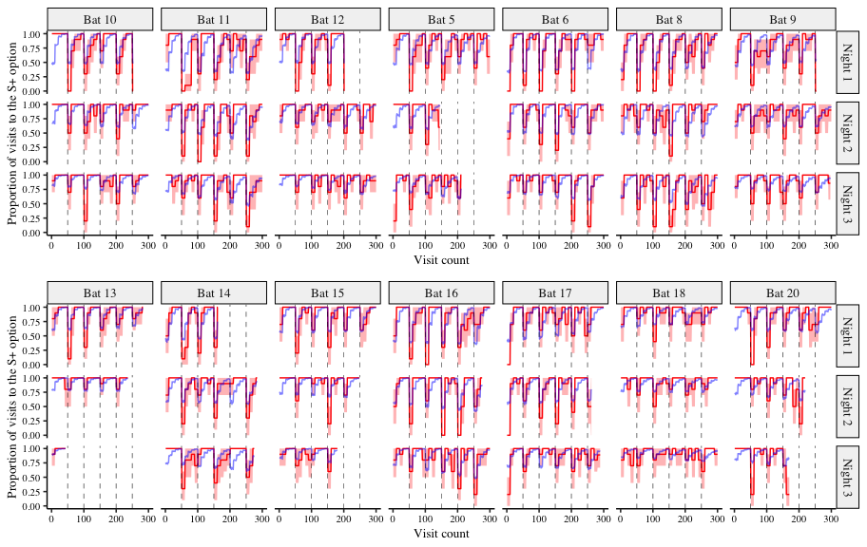

Figure 12: A comparison of the posterior predictions of the generalized linear mixed-effects model of the visits to the rewarding option and the empirical data from the bats. The red line indicates the average proportion of visits to the rewarding option per bin made by the individual bats, with the red shading indicating 95% confidence intervals; the blue line indicates the corresponding posterior prediction of the model